**Netflix Movies & TV Shows Analysis — Final Report**

**Author:** Manasa Shetty

**Introduction**

In this project, I analyzed the Netflix Movies and TV Shows dataset to identify content distribution trends, popular genres, regional contributions, and release patterns. My goal was to understand what kind of content dominates Netflix, which countries and directors contribute the most, and how releases have varied over time.

**Dataset Description**

The dataset contained **8,790 records × 10 columns**.

**Columns:**

* show_id — Unique ID for each show
* type — Movie or TV Show
* title — Title of the content
* director — Director of the show/movie
* country — Country of origin
* date_added — Date added to Netflix
* release_year — Year of release
* rating — Content rating (e.g., TV-MA, PG-13)
* duration — Length (minutes for movies, seasons for TV shows)
* listed_in — Genre/category

The dataset was clean with no missing values. I dropped duplicates and standardized columns for analysis.

**Exploratory Data Analysis**

**Content Distribution Over Years**

* A large number of Netflix movies were released around **1970**.
* More recent years have steadily increasing content, showing Netflix’s growth in acquiring diverse content.

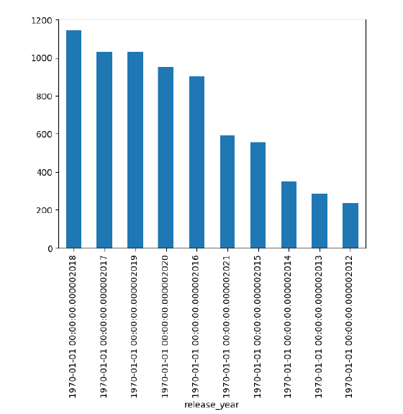**Observation:** The number of titles has increased significantly since 2000, reflecting Netflix’s aggressive content expansion strategy.

**Country-wise Contribution**

* **United States** dominates Netflix’s catalog, followed by India, UK, and others.
* Top 7 countries together contribute the majority of Netflix’s content.

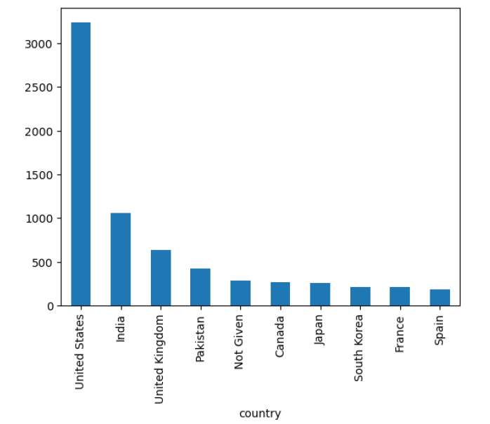

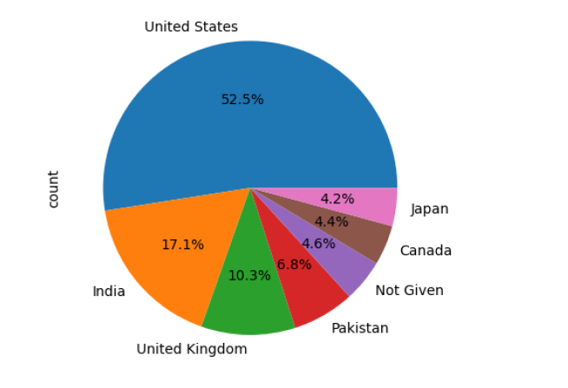

**Observation:** The US contributes the largest share, but India and the UK highlight Netflix’s global reach.

**Ratings Analysis**

* The most common rating is **TV-MA (3,205 titles)**, followed by **TV-14 (2,157 titles)** and **TV-PG (861 titles)**.
* This shows Netflix primarily features **mature content targeted at adults and young adults**.

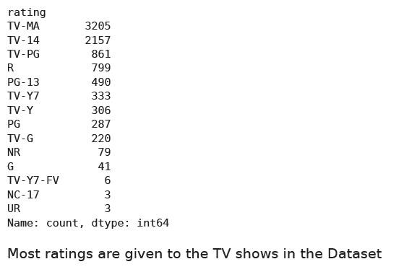

**Observation:** Adult-oriented categories (TV-MA, TV-14) dominate, showing Netflix’s focus on mature audiences.

**Content Categories**

* **Top categories:** Dramas and International Movies dominate Netflix’s library.
* Other significant categories include Documentaries, Comedies, and Action/Adventure.

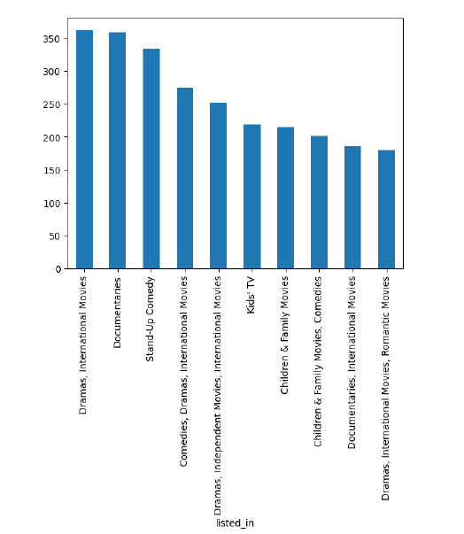**Observation:** Drama and international content clearly dominate, reflecting Netflix’s global storytelling focus.

**Directors with Most Releases**

* **Rajiv Chilaka**, **Alastair Fothergill**, and **Raúl Campos & Jan Suter** are among the most frequent directors.
* Notable global names like **Martin Scorsese** and **Steven Spielberg** also appear in the top list.



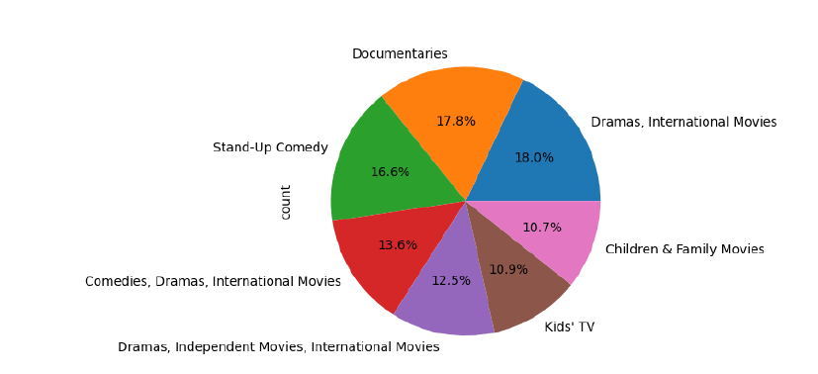

**Observation:** Certain directors, especially from India and documentary filmmaking, contribute a high number of shows.

**Genre Insights**

* **Top Movie Genres:** Dramas, Comedies, and Documentaries are the most frequent.
* **Top TV Show Genres:** International Dramas, Reality TV, and Kids’ TV dominate.

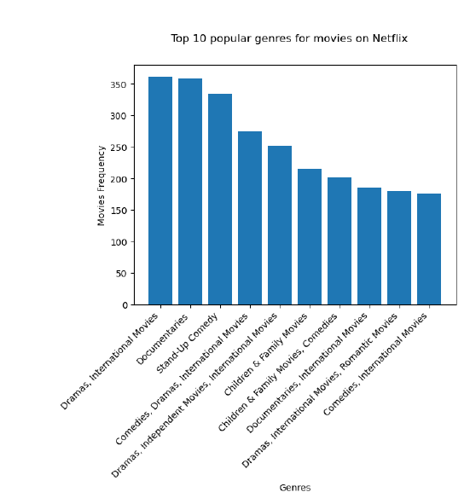

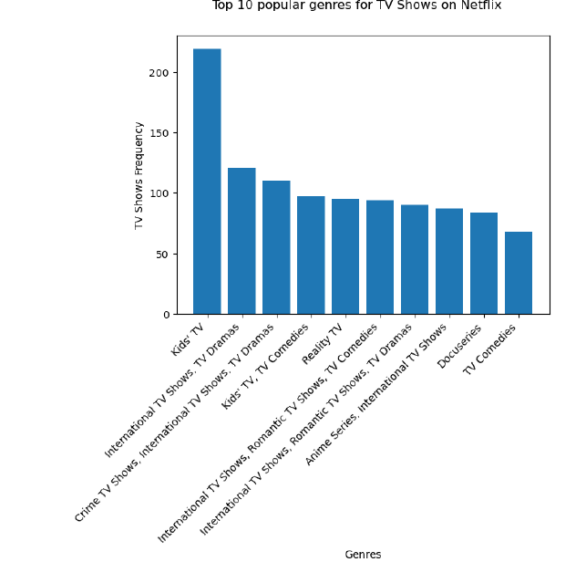  
**Observation:** Movies lean toward Drama and Documentaries, while TV Shows focus on kids’ and international audiences.

**Yearly Releases (Netflix Catalog Growth)**

* Netflix saw a clear **growth trend in yearly releases** of both Movies and TV Shows over the past two decades.
* TV Shows have increased significantly in the last decade, highlighting Netflix’s shift toward series production.

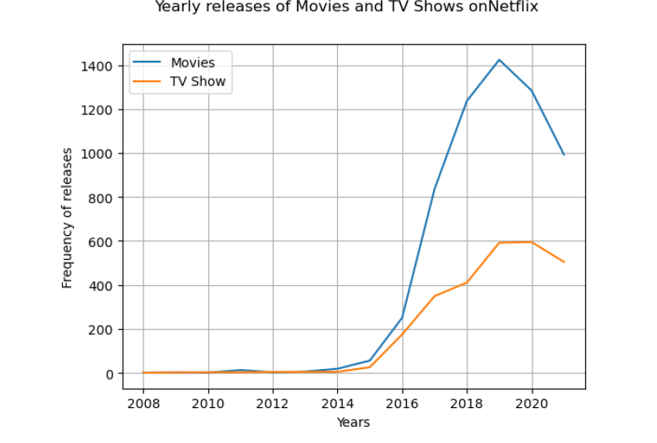  
**Observation:** A sharp rise after 2015 indicates Netflix’s transition from movie acquisitions to producing original TV series.

**Monthly Releases**

* Releases occur consistently throughout the year, but **September and December show noticeable spikes**, likely due to fall premieres and holiday releases.

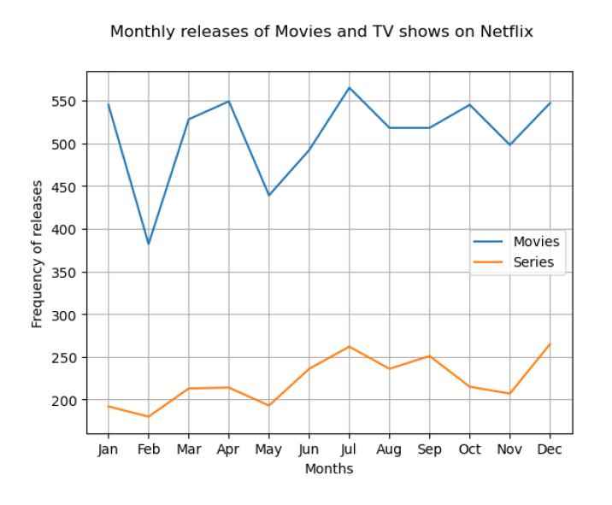  
**Observation:** The December peak aligns with holiday-season releases, while September marks the start of fall TV schedules.

**Key Observations**

* United States leads in contributing Netflix content, but international movies/series are also strongly represented.
* Netflix caters primarily to adult and teen audiences, with TV-MA and TV-14 dominating ratings.
* Drama is the most popular genre across both Movies and TV Shows.
* The number of Netflix Originals and acquisitions has increased steadily year-over-year, especially for TV Shows.
* Certain directors and production houses contribute frequently to Netflix’s catalog.

**Limitations**

* The dataset does not include viewership statistics, so popularity cannot be directly measured.
* The listed_in (genre) field often contains multiple genres, requiring more advanced NLP for precise categorization.
* Data only goes up to the date of collection (no real-time updates).

**Conclusion**

Through this project, I discovered that Netflix has grown rapidly over the years, with its catalog dominated by Drama and International content. The US remains the largest contributor, but Netflix’s global reach is evident through diverse content from many countries. The rating distribution confirms Netflix’s focus on adult and teen-oriented content.

Analyzing yearly and monthly trends showed Netflix’s consistent growth in both Movies and TV Shows, with TV content growing more aggressively in recent years. These insights help explain Netflix’s content strategy: building a strong international catalog, targeting a global audience, and balancing movies with a heavy emphasis on TV series.

**Future Work**

* Incorporate viewership data (if available) to identify not just what is on Netflix, but what audiences actually watch.
* Apply text analysis/NLP on genres and descriptions for more refined clustering of content.
* Compare Netflix’s catalog with competitors (Amazon Prime, Disney+) for market benchmarking.
* Study time-to-Netflix (release year vs date added) to analyze how quickly content is acquired.

**Code & Output**

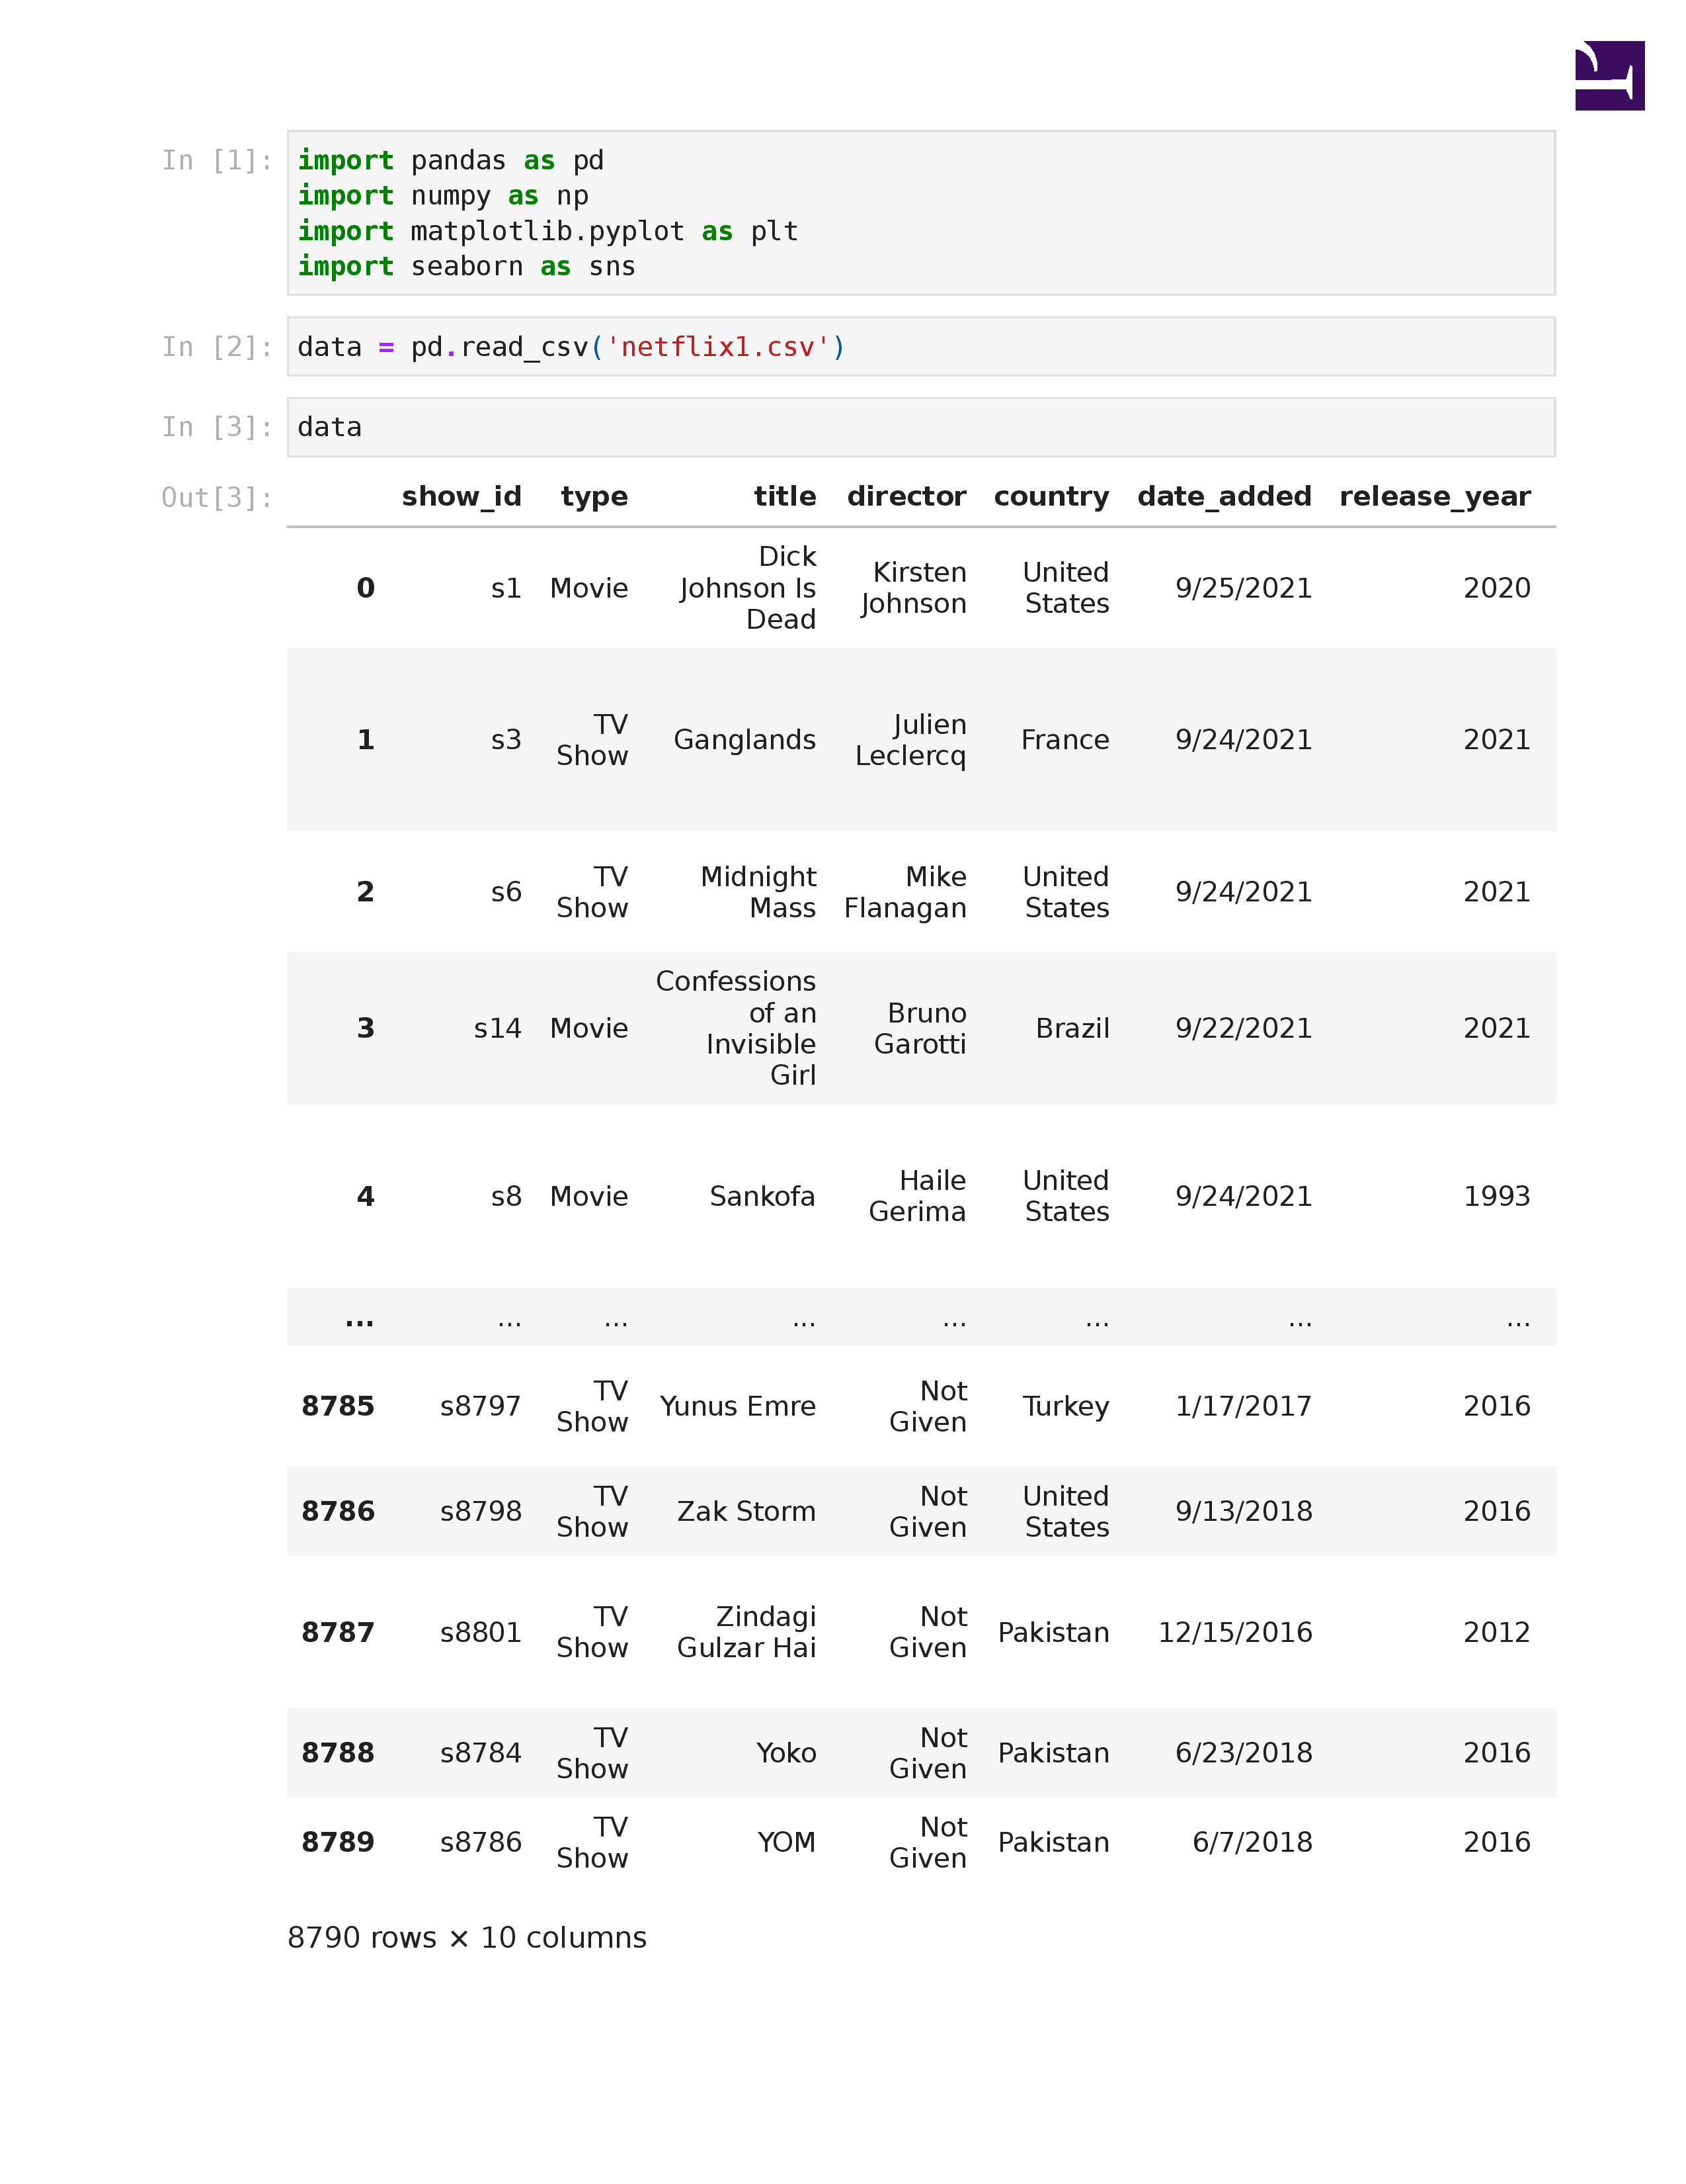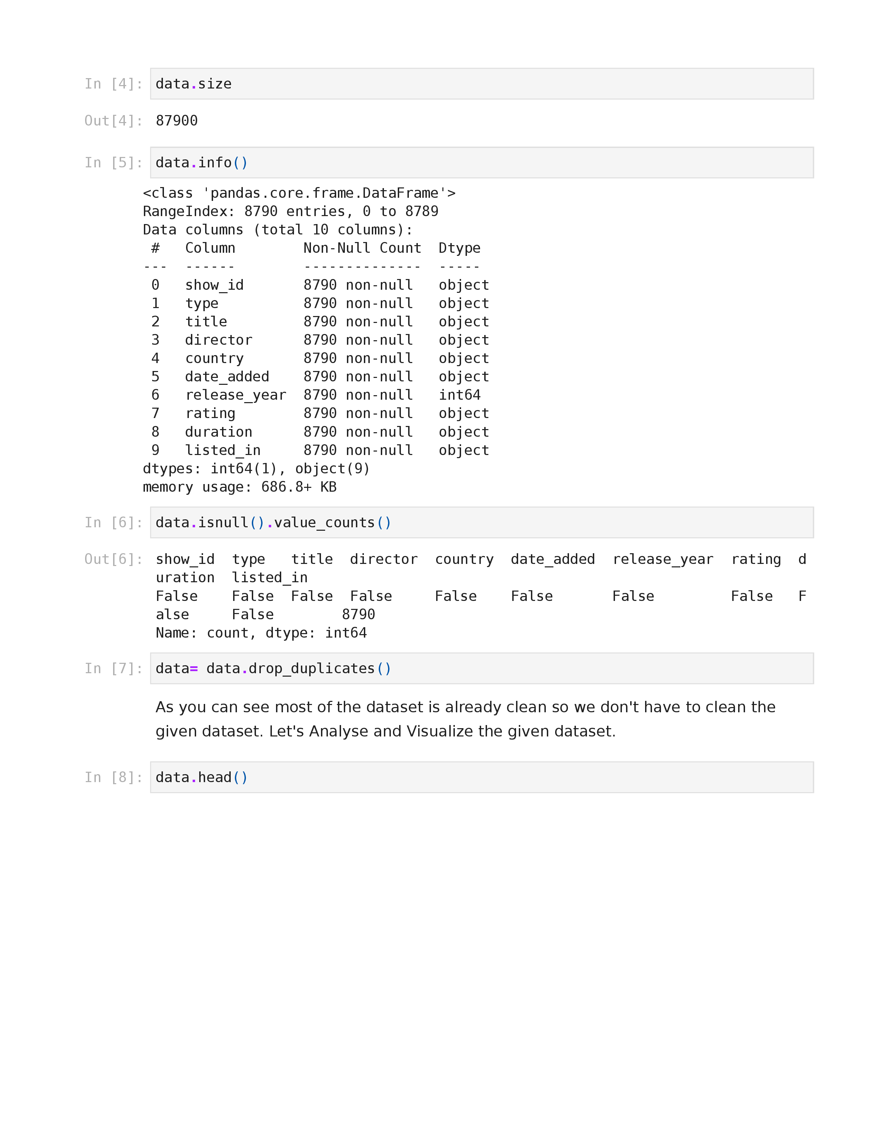 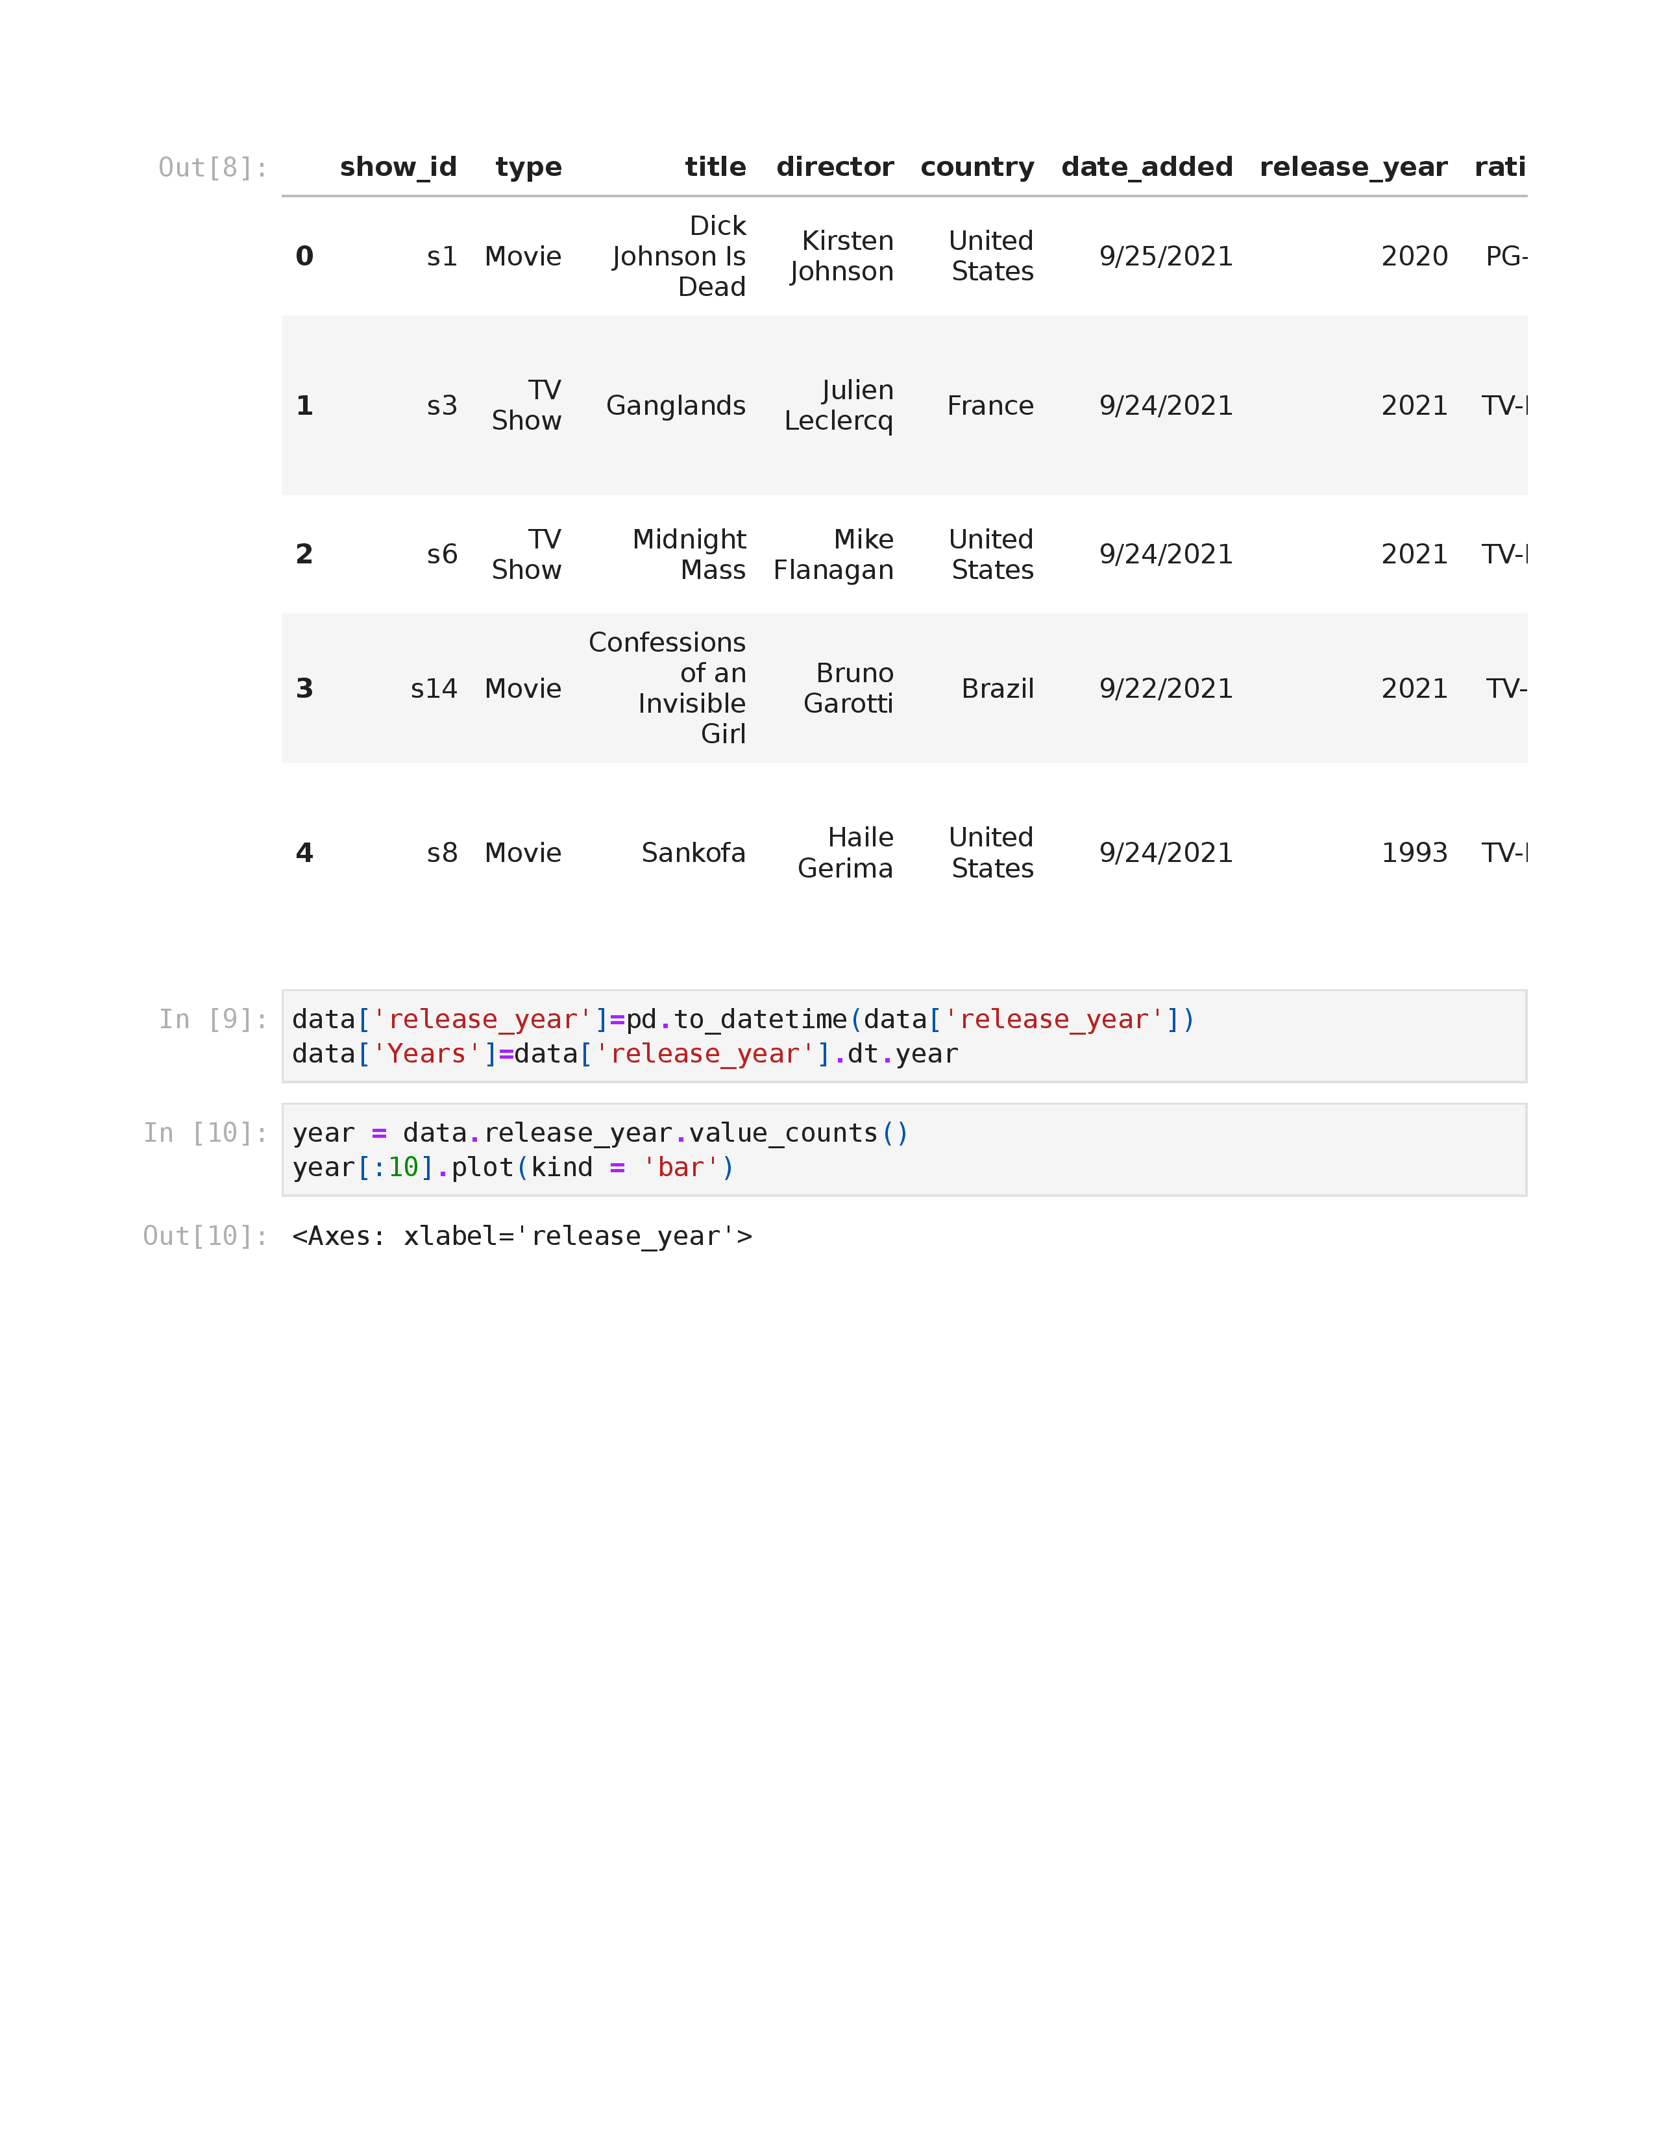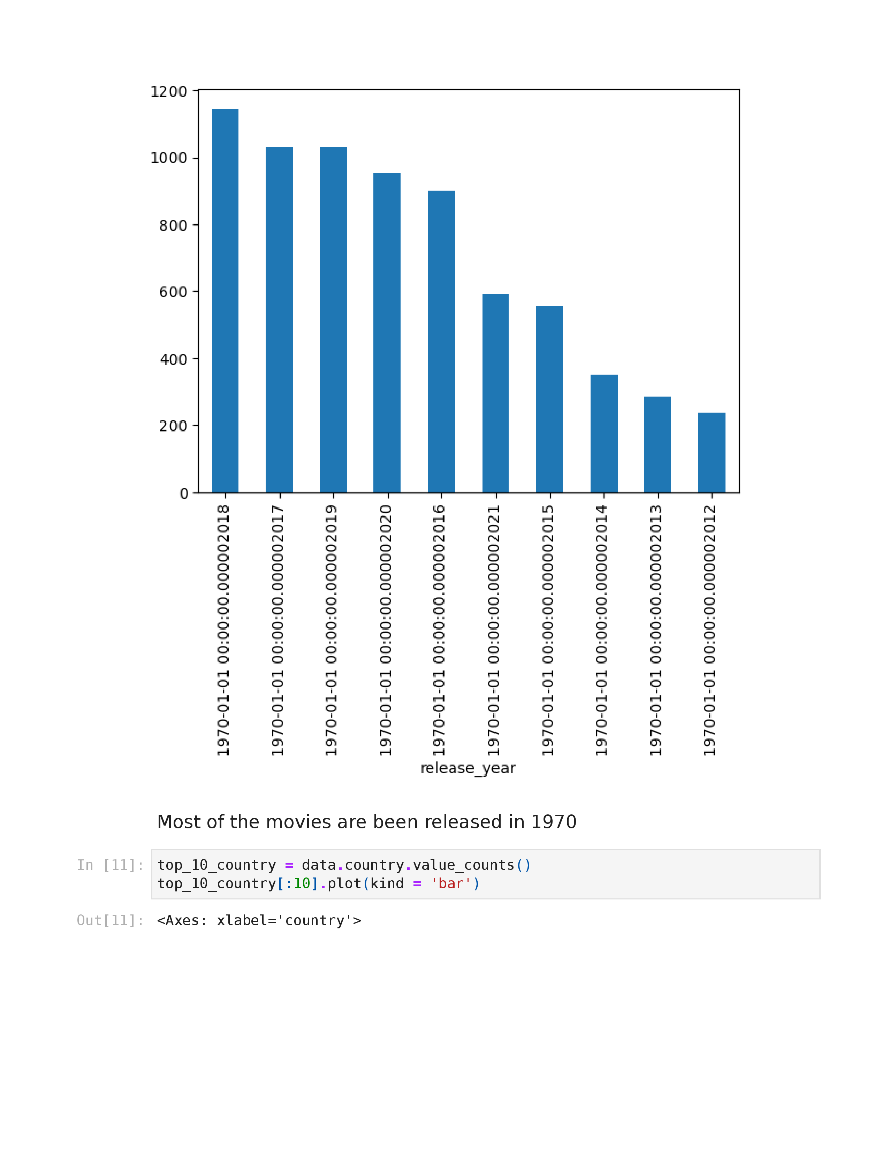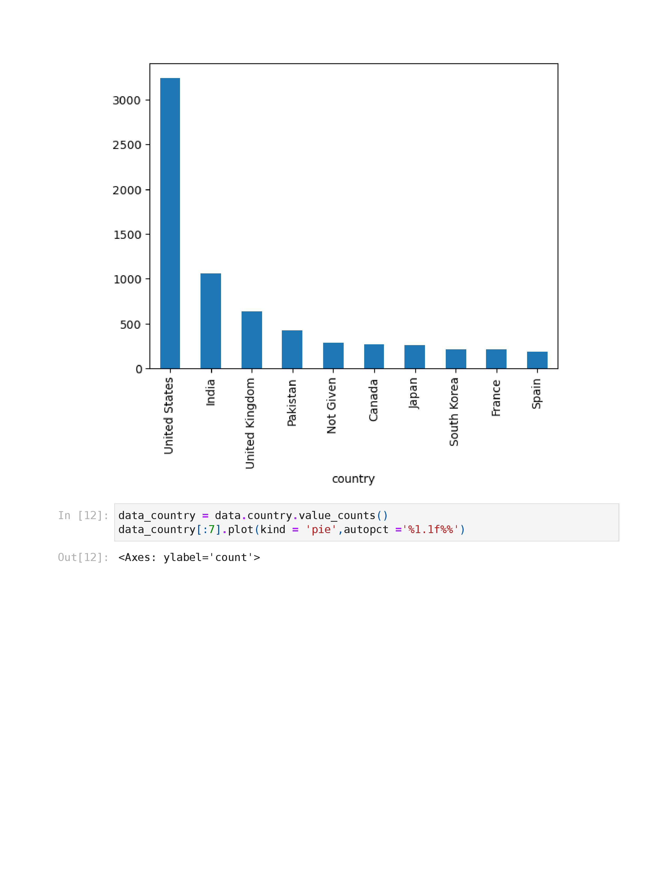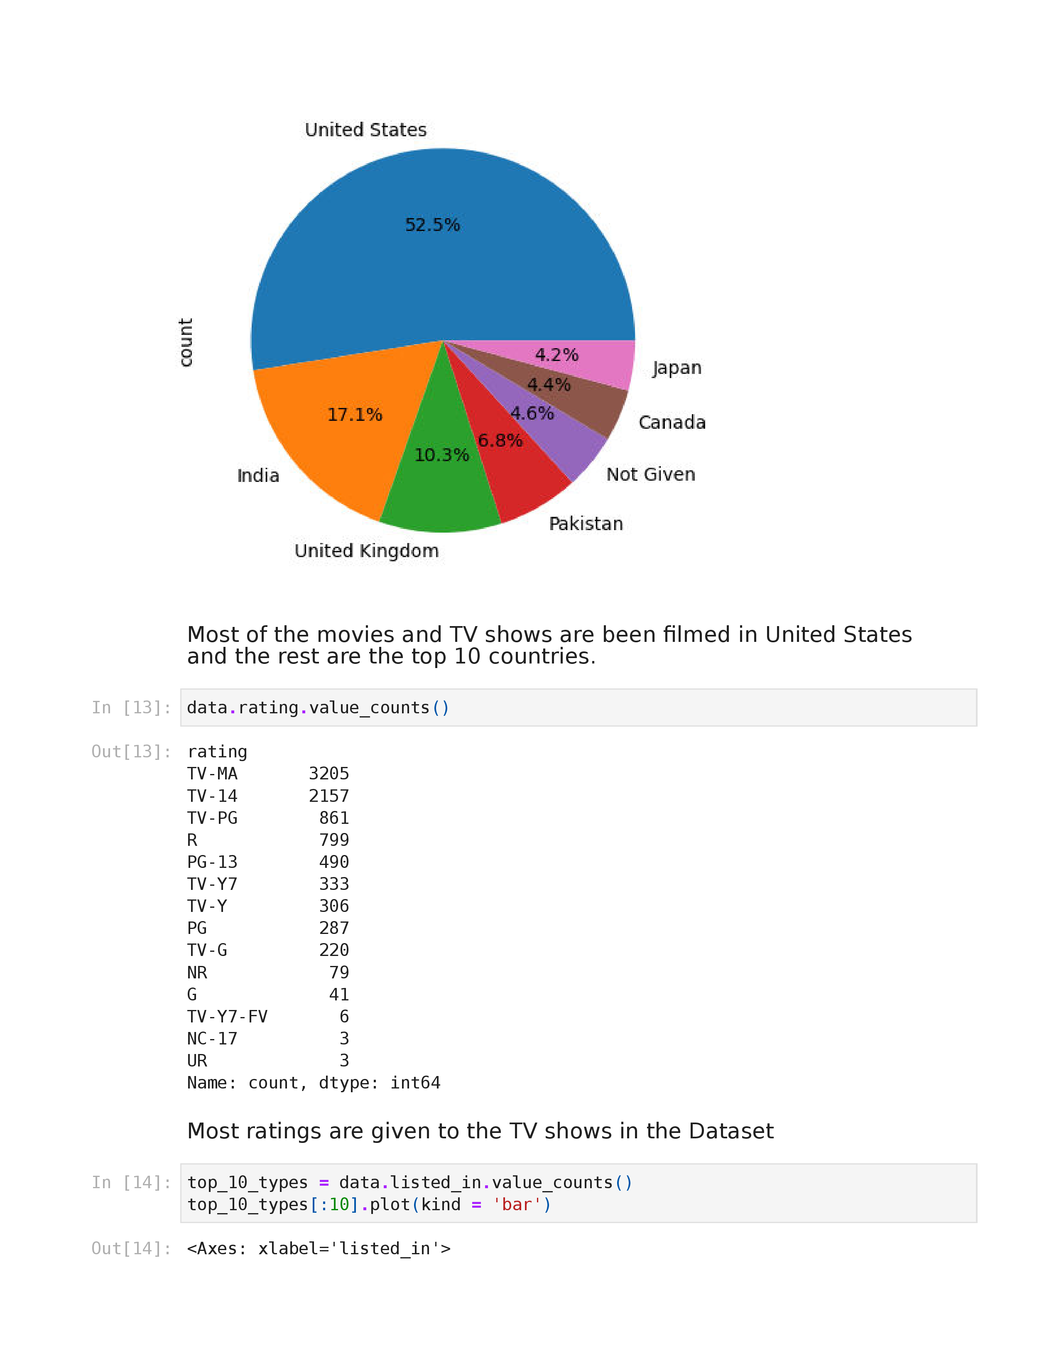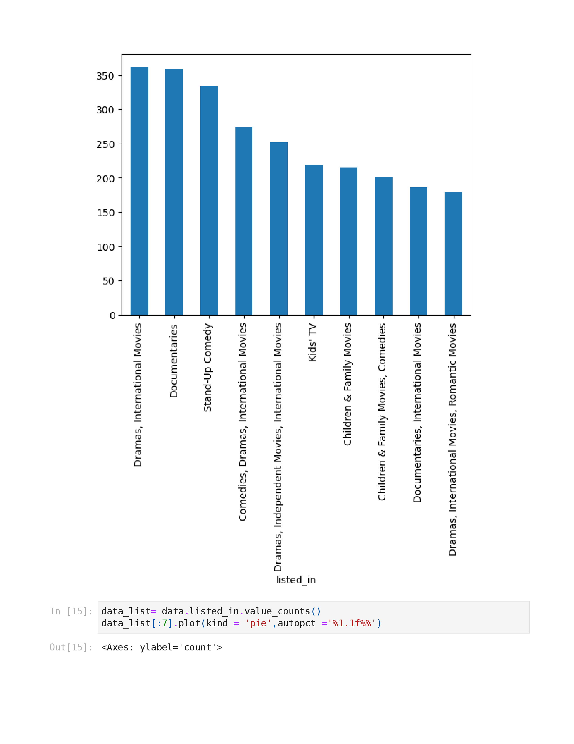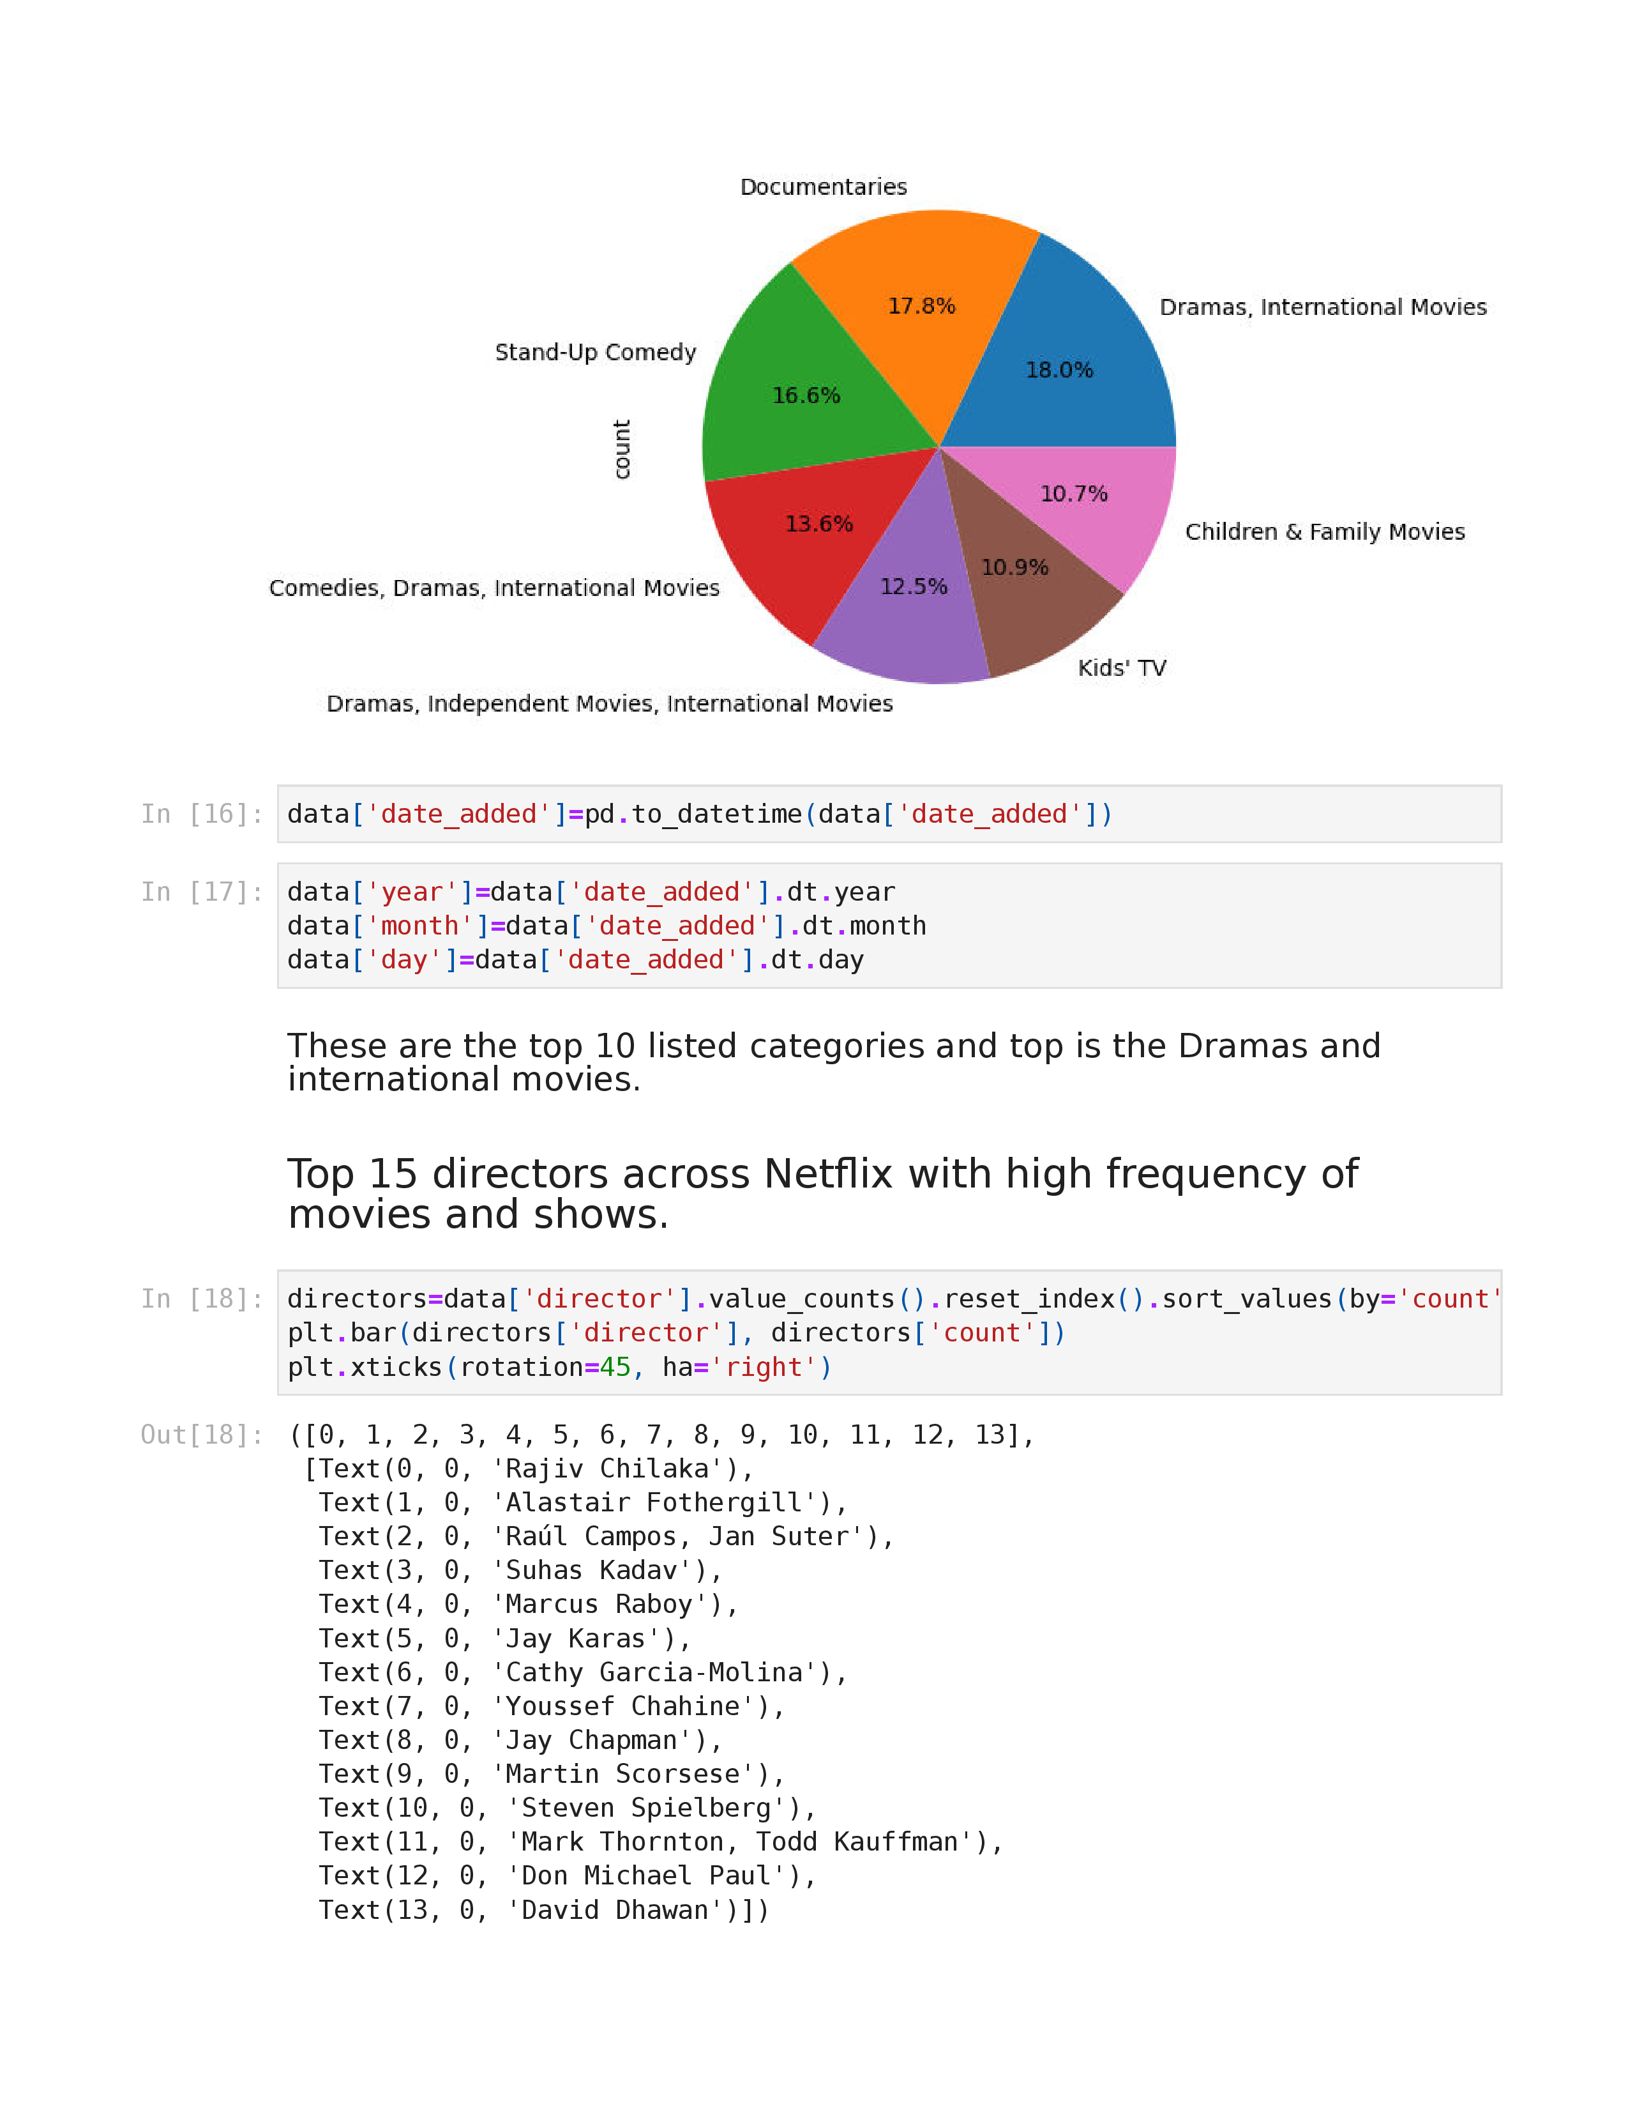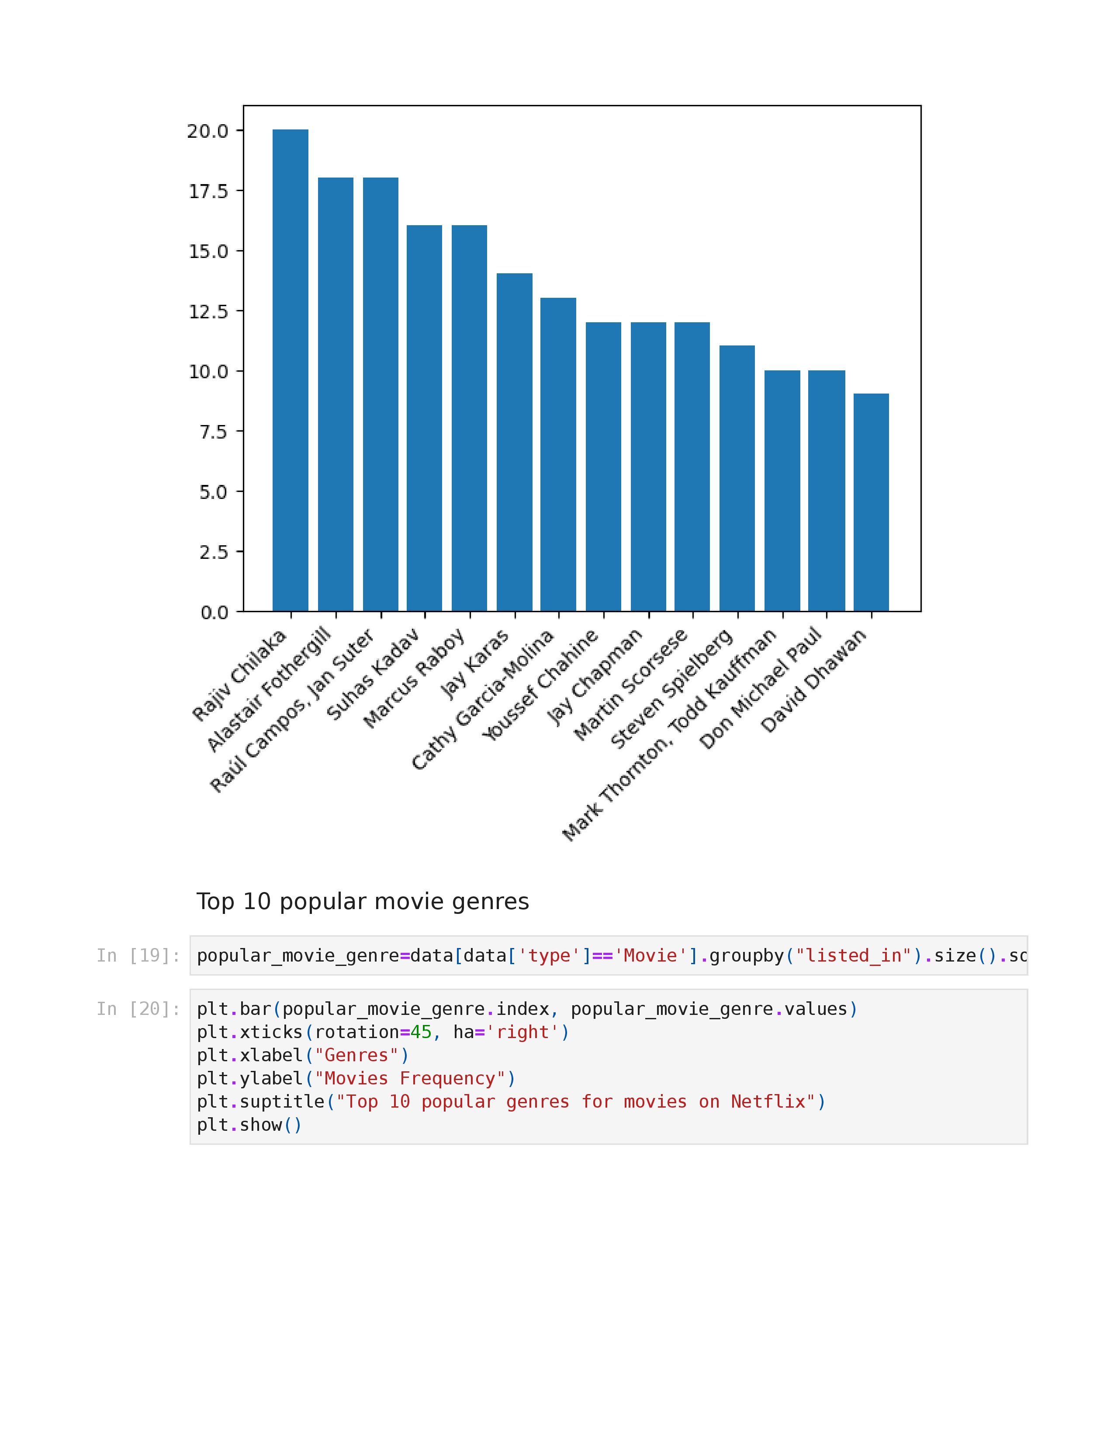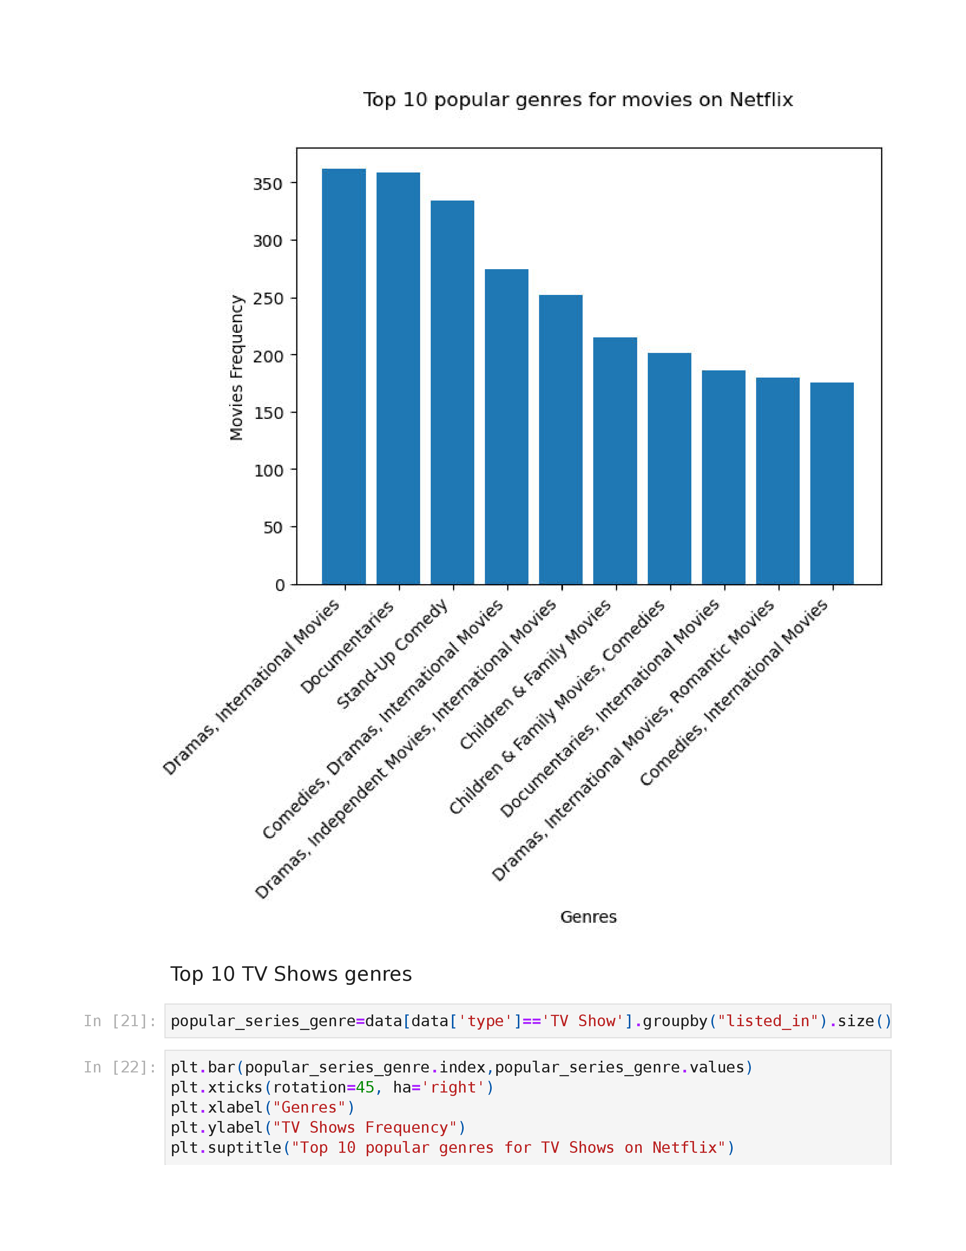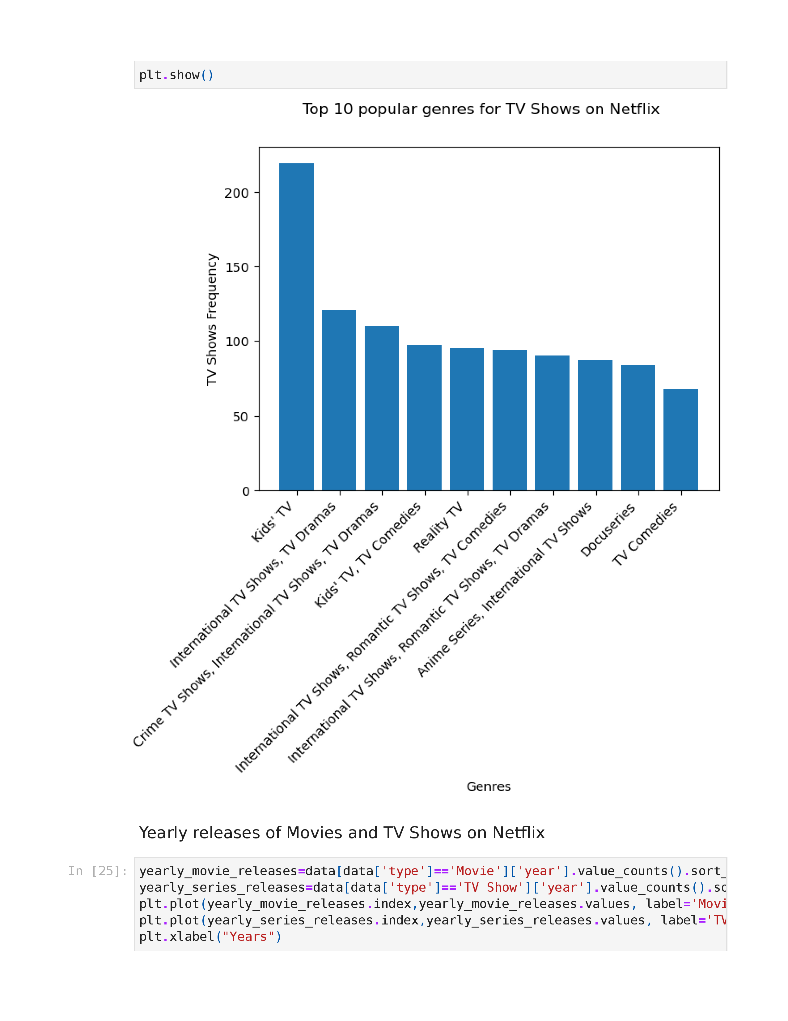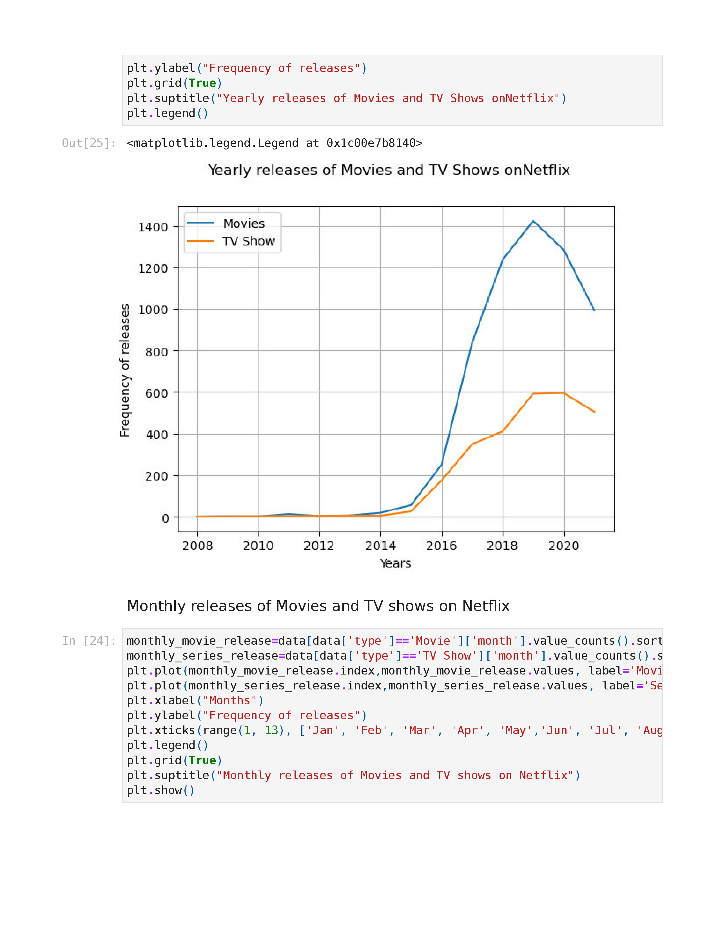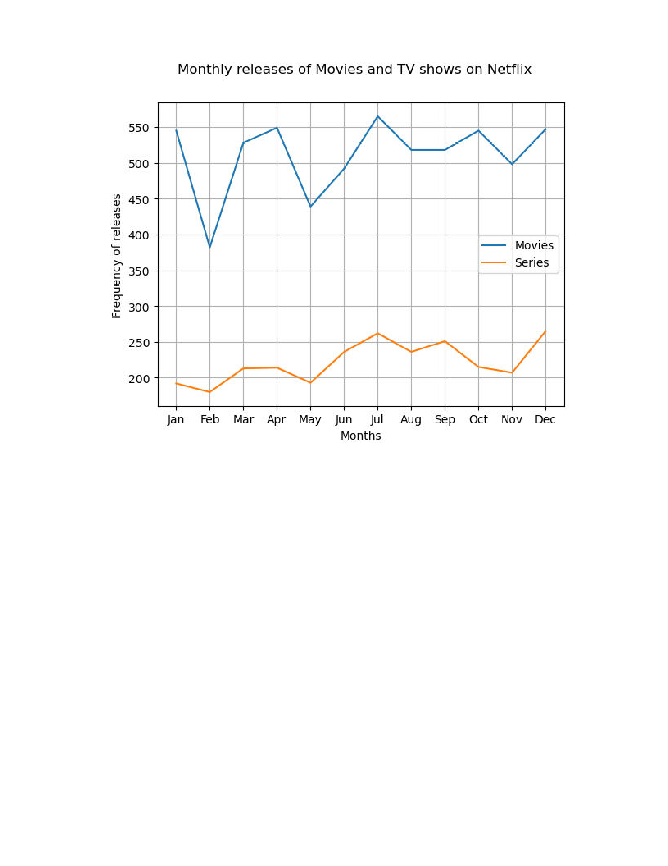

GitHub Link: <https://github.com/Manasashetty01/Netflix-data>